SOCIAL DEVEPMENT LESSON NOTES FOR BABAY CLASS TERM ONE 2026

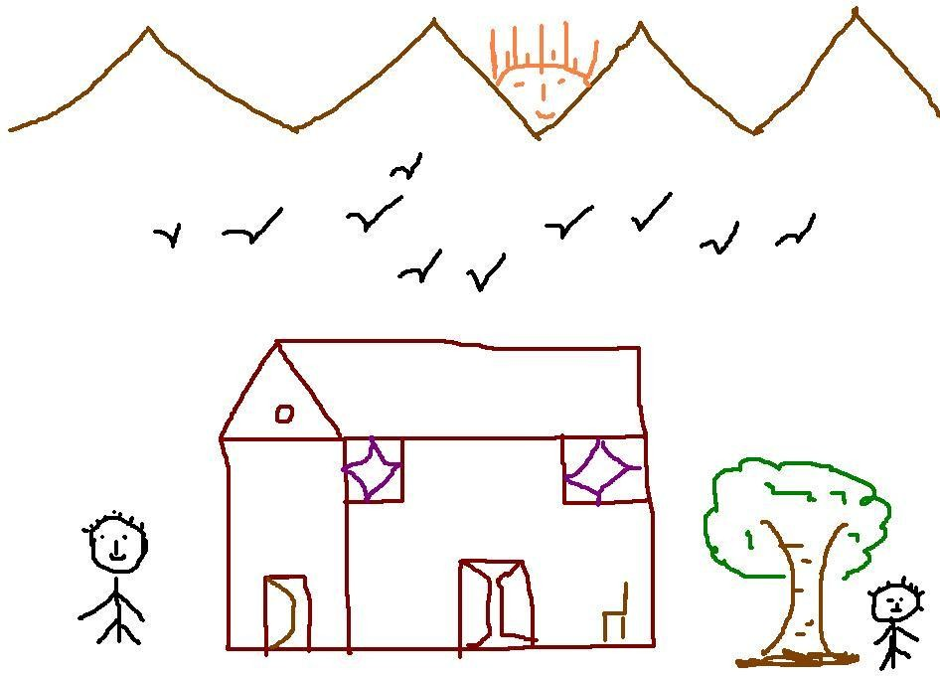
LEARNING AREA 2 (LANGUAGE DEVELOPMENT I) INTERACTING WITH,EXPLORING,KNOWING AND USING MY ENVIRONMENT.
TERM I

WEEKII
Suggested developmental activities
- Naming rooms in the house e.g.kitchen,bedroom,sitting room
- Naming and counting number of houses at home
- Colouring pictures of houses
- Tracing pictures of different houses.

Oral naming of things found at home.

 | 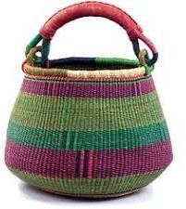 |  | 
 | 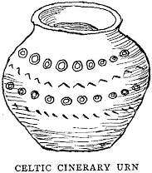 |  | 
Activity

Color our home.

Colour the things we find in the sittin | G room.
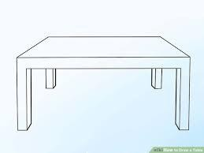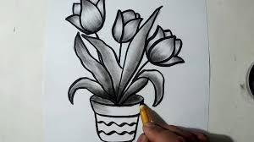WEEKIII

Suggested developmental activities
- Tracing things found at home
- Matching the things found at home
- Drawing the things found at home
- Circling the different
- Circling the same things found at home

Activity
Tracing things found at home.
Matching the same things found at home
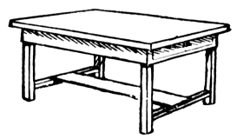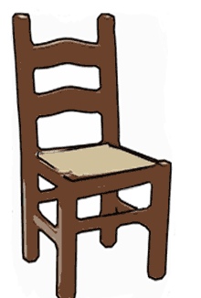

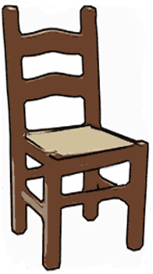WEEKIV
Identifying things found at home i.e.

 | 

Activity
Match the same pictures

Activity:
- Draw and shade
- Pasting
- Find the missing parts
- Molding
- Tearing
- Circle the same
- Drawing pictures
-

WEEKV
OURSCHOOL
Naming things found in our classroom
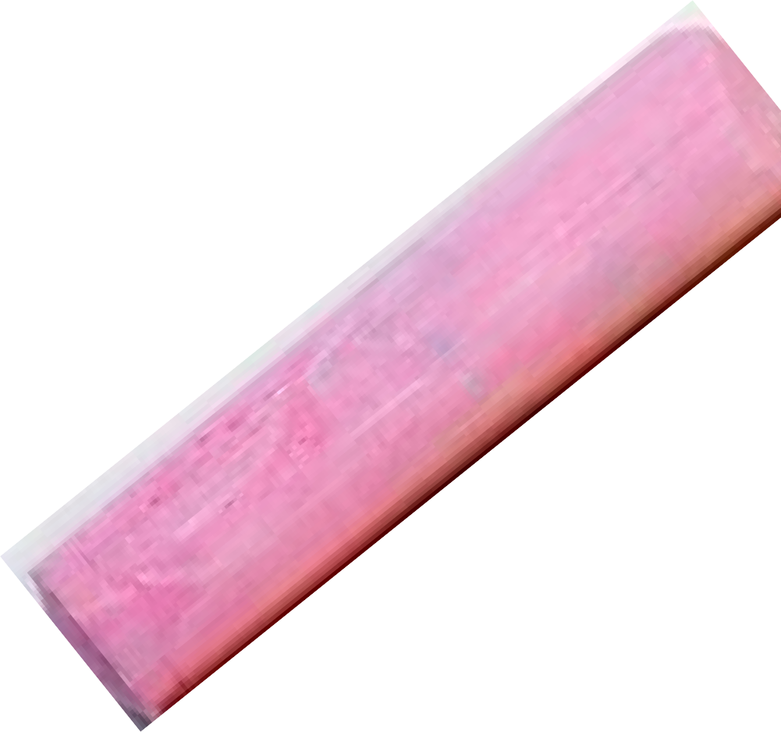 | 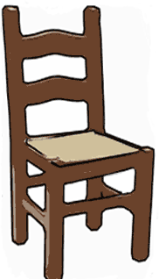
 | 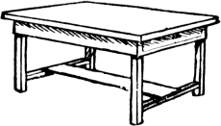 |  | 

Suggested developmental activities
- Naming orally
- Shading
- Matching
- Tearing
- Pasting
- sorting
- Circle the same pictures

Activity
Circle the same pictures

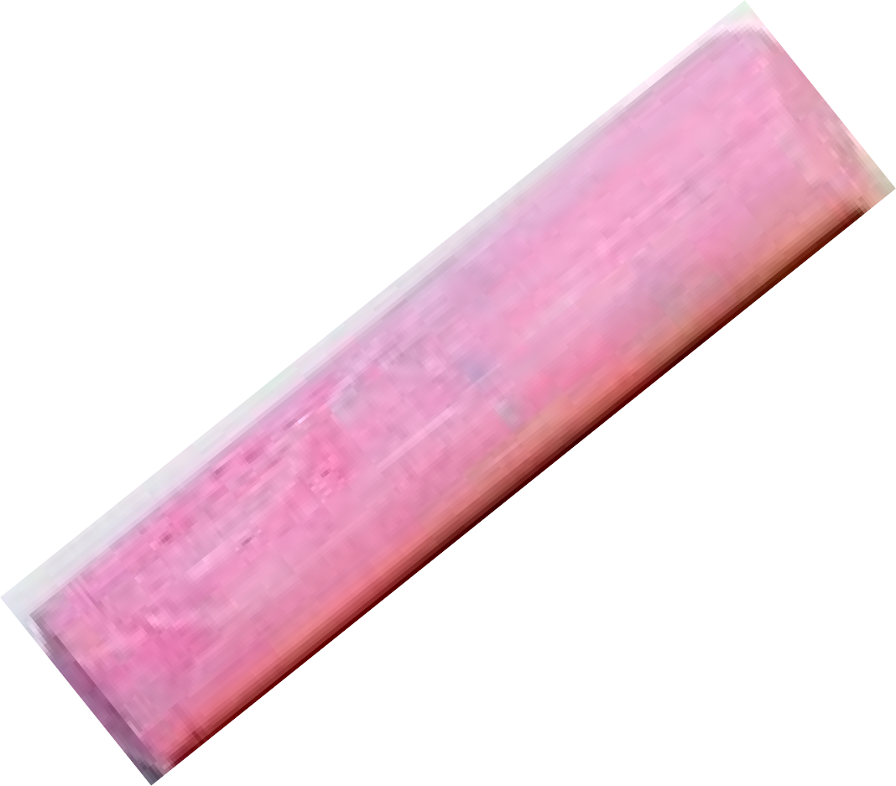 | 
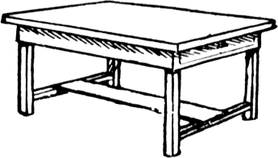 | 

Shade the picture

WEEKVI
Things found in our classroom(Tracing)
Suggested developmental activities
- Naming orally
- Match the same
- Tick the same
- Draw simple pictures
- Sort pictures/objects
- Find the missing parts
- Shade
- Identify
- Sand play Activity
Trace things found in class
WEEKVII
Oral naming people found at home
Introduce the lesson with a rhyme or a song related to the developmental activity.e.g.
“Who made you and m ex 2
Our father God
Who made mother and father
Our father God”

 | 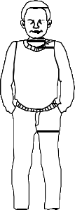 | 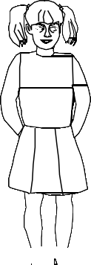 | 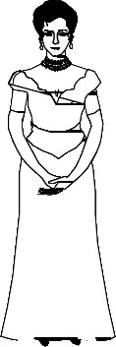

Suggested developmental activities
- Naming orally
- Shading
- Roleplaying
- Matching
- Sorting
- molding
- Tick the same
- Draw missing parts

Activity
Match the same family members

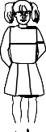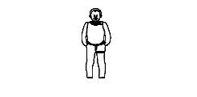

Shade me please


WEEK VIII
Things we wear
 |  |  |  | 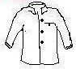 | 
 |  |  |  |  | 

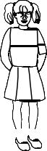Suggested developmental activities
- Naming orally e.g.shirt, dress,tie,etc.
- Tracing
- Shading
- Pasting
- Drawing
- Matching to the belonging

Activity
Match to the belonging

Circle the same
Trace a skirt

WEEK IX
Naming animals found at home

 | 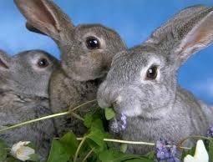 |  |  | 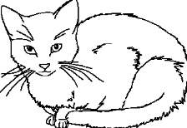
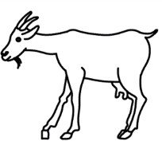 |  | 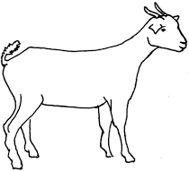 | 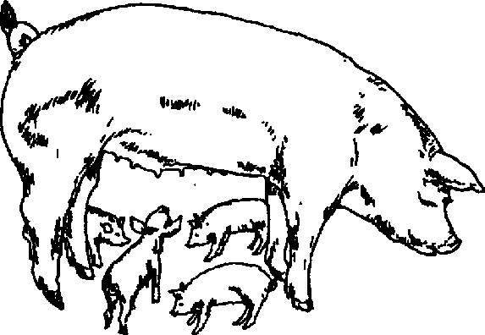 | 

Suggested developmental activities
- Naming orally
- Shading
- Sorting
- Matching
- Imitating
- Animal sounds e.g. moo, mee ,etc.
- Pasting
- Identifying animals

Activity
Matching the same pictures

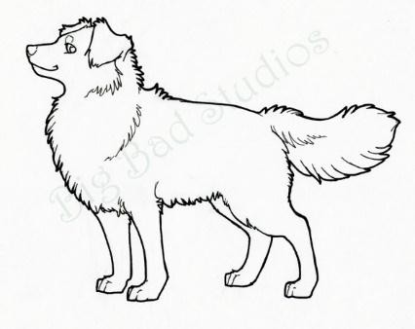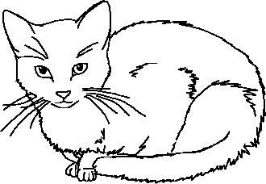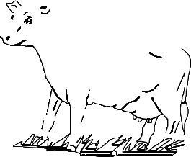

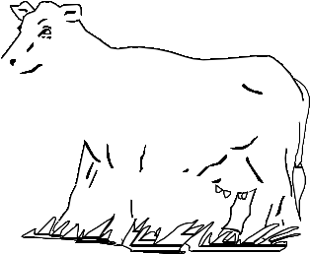
Match animals to their babies



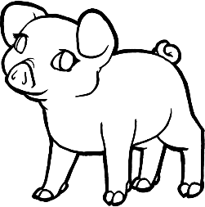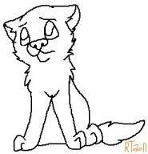


WEEK X
Knowing and appreciating important places in my environment
Suggested developmental activities
- Talking about different places in my environment for example school, hospital , church, and mosque.
- Drawing pictures, shading pictures and tracing pictures of the important places.
- Singing songs about important places for example
“my school ,my school I love my school………”
Activity
Shade the school
